To: | Cabinet – 13 March 2024  Council – 18 March 2024
Report of: | Executive Director (Development)
Title of Report: | Appropriation of Land at Railway Lane

Summary and Recommendations
Purpose of report: |  | The report seeks approval to appropriate a parcel of land (change the statutory basis on which it is held by the Council from one function to another) at Railway Lane from the General Fund to the Housing Revenue Account in order that the land can be used for the development of new council housing, and to update Cabinet on certain aspects of the development.
Key decision: |  | No
Cabinet Member: |  | Councillor Linda Smith, Cabinet Member for Housing  Councillor Ed Turner, Deputy Leader (Statutory) - Finance and Asset Management
Corporate Priority: |  | More Affordable Housing and Meeting Housing Needs
Policy Framework: |  | Housing and Homelessness Strategy 2023 to 2028
Recommendation: That Cabinet resolves to:
1. | Recommend to Council the appropriation of the land owned by Oxford City Council that forms part of the development site for housing at Railway Lane from the General Fund (GF) into the Housing Revenue Account (HRA) at the established red book valuation figure.

Supplementary valuation information (forthcoming)
Appendix 1 (Confidential) | Red Book Valuation

Introduction and background
- The Council continues to develop a supply programme to deliver more affordable housing through multiple work streams, including the delivery of homes through the Council’s housing company – OCHL; direct delivery by the Council; joint ventures; regeneration schemes; acquisitions; and enabling activity with Registered Providers, Community-Led Housing groups, and other partners. The Council seeks to deliver over 1,600 affordable tenure homes across the next four years (to March 2027), with at least 850 of those at the most affordable Social Rent level.
Scheme information
- This report relates to one development in the OCHL programme, Railway Lane, which will be ready to enter into contract shortly. The scheme secured project approvals and delegations at Cabinet on 14 December 2022, and the Council’s Planning Committee in July 2022 under planning reference 21/01176/FUL.
- This is a 100% affordable housing scheme of 90 much needed affordable homes. There is a mix of unit types from 1-bedroom flats to a 5-bed house. 47 homes are to be let at Social (Council) Rents to households on the housing register, and the remaining homes are to be developed as Shared Ownership tenure. The scheme uses derelict brownfield land.
- Accommodation schedule
Size | Social Rent | % | Shared Ownership | % | Totals | %
1b2pF | 8 | 8.8 |  |  | 8 | 8.8
2b3pF |  |  | 24 | 26.8 | 24 | 26.8
2p4bF | 8 | 8.8 |  |  | 8 | 8.8
2b4pH | 3 | 3.3 | 3 | 3.3 | 6 | 6.6
3b5pH | 18 | 20 | 16 | 17.9 | 34 | 37.9
4b6pH | 9 | 10 |  |  | 9 | 10
5b8pH | 1 | 1.1 |  |  | 1 | 1.1
Totals | 47 | 52% | 43 | 48 | 90 | 100

- The scheme is part of the Homes England Affordable Housing Programme 2021 – 2026 and has secured total grant of £6,165,000.
- The majority of the Railway Lane development site is owned by W.E Black Limited. They have agreed terms for the sale of their land to Oxford City Housing (Development) Limited (OCHDL), and their subsidiary company (Cantay Estates Limited) will be appointed by OCHDL under the sale and development agreement to construct the development in accordance with planning. A small parcel of land comprised in the development site (by Thompson Terrace) is in the ownership of Oxford City Council. This parcel of land (identified below in Image 1, edged in blue) is currently held in the General Fund.
- This report requests that Cabinet note the intention to commence the appropriation process for this land from the General Fund to the Housing Revenue Account, and requests that Cabinet recommends this to Council.
- There will be no sale of the OCC land. Instead, the Council will grant the developer rights to implement the development on the Council’s land under licence. The contract between OCHDL and the developer will oblige OCHDL to procure the grant of this licence.

Site location plan
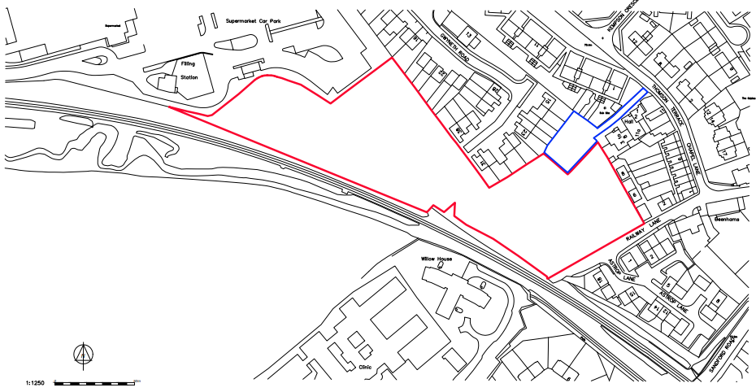
Image 1: OCC land identified in blue (wider site identified in red)
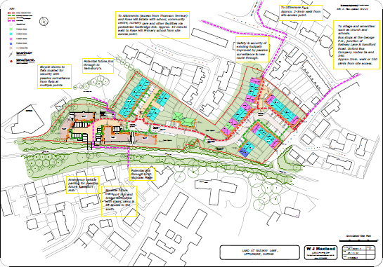
Image 2: Site plan to indicate development on OCC parcel of land
Financial implications
- The land will be appropriated from the General Fund to the HRA at a value equal to that of a Red Book valuation.
- The Red Book valuation is underway but the valuation figure is not yet available. The valuation figure will be circulated separately and confidentially in advance of Cabinet.
- The appropriation will result in an increase to the HRA Capital Financing Requirements (CFR) of the valuation figure and a corresponding decrease in the General Fund CFR.
- The development of the land will be completed in phases, and will involve stage payments being made by OCHDL to the developer at agreed intervals set out in the sale and development agreement (Contract 1). There will be a separate contract between OCHDL and the Council for the buy-back of the affordable homes (Contract 2), which will be entered into at the same time as Contract 1. Contract 2 will oblige the Council to make stage payments to OCHDL at the same intervals, to enable OCHDL to comply with their obligations under Contract 1.

Legal issues
- The Council has the power to acquire and hold property for various statutory purposes to perform its functions, In order to use land for a purpose other than the one for which it was acquired the land must be “appropriated” for a different purpose. Appropriation is a statutory process which allows the Council to reallocate property within its ownership from one purpose to another.
- It is entirely within the Council’s discretion to decide that a certain parcel of land or a certain property that has been acquired or held for one purpose should now be used or appropriated for another purpose. The Council is the sole judge of whether or not the land is still required for the purpose for which it is held and its decision cannot be challenged, other than by way of a judicial review if the decision is made outside the Council’s powers or the relevant procedural requirements have not been complied with.
- The general power of appropriation is set out under section 122 of the LGA 1972. Under this section appropriation may be made where the land is no longer needed in the public interest of the locality for the purpose for which it is held immediately before appropriation. In this regard, a broad view of local need (taking account of the interests of all residents in the locality), has to be taken and officers consider that this test has been met. Officers are also satisfied that the use of appropriation would be in the public interest and proportionate to the objectives of the redevelopment scheme for the purpose of the Human Rights Act 1998.
- Appropriation to the HRA (as proposed here) is specifically dealt with under Section 19 (1) of the Housing Act 1985, and gives the Council the power to appropriate for housing purposes any land for the time being vested in them or at their disposal. Consent of the Secretary of State is not required to appropriate land to the HRA, however once land is appropriated to the HRA any later appropriation or disposal for another purpose would require the consent of Secretary of State.
- The Council minutes should show that the land is not currently held for housing purposes and that the Council intends to formally appropriate the land in accordance with s19 (1) HA 1985.
Level of risk
- Any risks inherent in this programme are already identified elsewhere, with actions to mitigate these detailed in the OCHL and HRA Business Plans and the Council’s Medium Term Financial Plan.

Equalities impact
- There are no adverse impacts in undertaking this activity, with the potential to improve provision for persons in housing need, through the provision of more affordable and accessible housing to better meet client needs.
Carbon and Environmental considerations
- There are no carbon or environmental considerations in relation to the appropriation.

Report author | Dave Scholes
Job title | Affordable Housing Supply Corporate Lead
Service area or department | Housing Services
Telephone | 01865 252636
e-mail | dscholes@oxford.gov.uk

Background Papers: None

